HAZARD reporting form
This form is for submitting confidential or voluntary occurrence reports or hazard reports to the SFS/ Lisama/ SAHOOA safety officer. You can file it at the SMS station or use this form and email to vispilot@hotmail.com
For incidents and accidents and mandatory occurrences please use the full report FSS GEN FORM 014 available on NCAA website, Lisama website or at the SMS station.
- Date and time UTC of occurrence or observation
...........................................................................
- Location (Airport or GPS co-ordinates)

............................................................................................……………
- Aircraft (vehicle) involved (Callsign, registration, type)

......................................................................................………………….........................................................................................................................................................................................................................

- Description of occurrence or hazard (Please give as much details as possible)
....................................................................................................................................................................................................................................................................................................................................................................................................................................................................................................................................................................................................................................................................................................................................................................................
- Can you provide a root cause of the occurrence or hazard? (Optional)

....................................................................................................................................................................................................................................................................................................................................
- Do you have any suggestions or recommendations for resolution or prevention or mitigation? (Optional)
............................................................................................................................................................................................................................................................................................................................................................................................................................................................................................................................................................

- What would be the most likely outcome? (Optional)

  - Catastrophic (Aircraft destroyed or fatalities)
  - Hazardous (major damage, permanent injury)
  - Major (minor damage, injuries requiring medical attention)
  - Minor (nuisance, disruption, use of emergency procedures)
  - Negligible (little or no consequences)

- Please rate the likelihood of a re occurrence. (Optional)

  - Frequent (once a month or more)
  - Occasional (once in any 3 month period)
  - Remote (once a year)
  - Improbable (once in 3 years)
  - Extremely improbable (greater than 3 years)

- Feedback. (Optional)

If you want feedback on this issue please provide your name, cell phone number and email address. (Optional)

...............................................................................................................................................................................................................................................................................................................................................................................................................................................................................................................

- Thank you
Thank you for submitting this report. Your contribution towards aviation safety is appreciated.

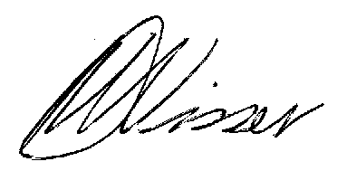
Dawid Visser
ASO: SFS, Lisama and SAHOOA
081 127 9214
vispilot@hotmail.com

